Getting Started For iOS
Welcome to Smartcare! This guide is to assist you with using the Smartcare Parent App for iPhone or iPad.
Upon enrollment in your childcare center you will receive a confirmation email with a link to set up your password and PIN. If you did not receive your confirmation email, please contact your childcare center.

System Requirements
The Smartcare Parent App works with iPhones and iPads installed with iOS 10 or higher:
- iPhone 6s  - iPhone 6s Plus  - iPhone 6  - iPhone 6 Plus  - iPhone SE  - iPhone 5S  - iPhone 5C  - iPhone 5 | - iPad Pro 12.9-inch  - iPad Pro 9.7-inch  - iPad Air 2  - iPad Air  - iPad 4th generation  - iPad Mini 4  - iPad Mini 3  - iPad Mini 2

Download the Application
- On an iOS device, open the App Store and search for “SmartCare for Parents.”
- Install the application. You may be prompted to enter your Apple ID and password.

Log In to Your Account
- Tap on the app to open it.
- Enter your email and password.
- Tap Login. The Timeline displays by default.

Reset Your Password
- On the Login screen, tap I Forgot Password at the bottom of the screen.
- Follow the prompts to reset your password.
| Smartcare Parent App iOS User Guide |

Log Out
- Tap Settings at the bottom of the screen. The Settings screen opens.
- Tap Logout and then Yes to confirm.

Change Your Password
- Tap Settings at the bottom of the screen. The Settings screen opens.
- Tap Change Password.
- Enter your current password.
- Enter your new password and then enter it again to confirm.
- Tap Change Password.

Technical Support

Access the User Guide
- Log in to the Smartcare for Parents app.
- Tap Settings at the bottom of the screen.
- Tap Support.
- Tap Download now! to open and view the user guide.

Report a Technical Problem
- Shake your phone until the How can we help you? prompt opens.
- Tap Report a Problem.
- Use the draw tools to mark up the screen shot if desired, then tap Report a Problem at the top.
- Enter your email and a description of the problem.
- You can also take a screen recording, take a photo, or attach a photo from your phone (tap the options at the bottom).
- Tap the Send icon at the top right of the screen.

Contact Us
Phone: 1-844-SMARTER

Using Parent App for iOS

Sign In/Out to Your Center
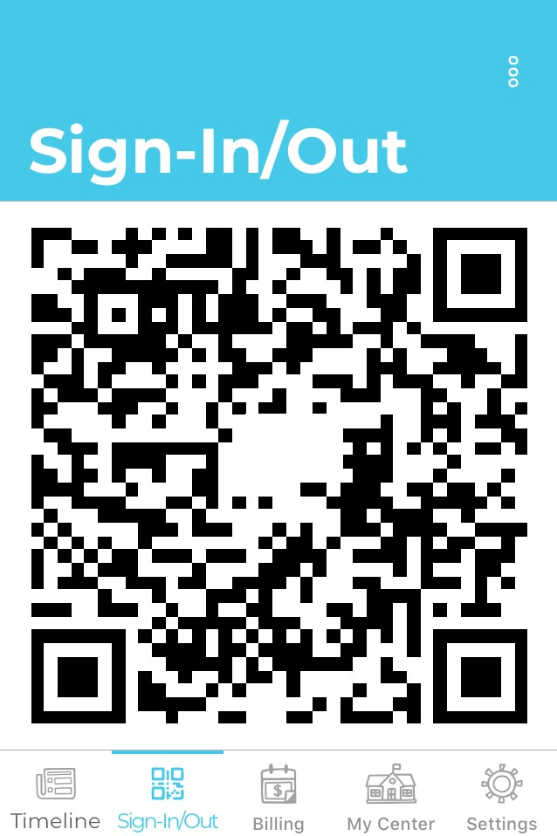
- Open the app and log in.
- Tap Sign-in/Out at the bottom menu. The QR code opens.
- Place the code in front of the Kiosk camera.
- Tap on the circle next to the child you are signing in or out.
- Tap Login. The Timeline displays by default.

Refresh Your QR Code
1. On the Sign-in/Out screen, tap the Refresh icon at the top. The QR code with automatically refresh.

Send Your QR Code for Emergency Pick-up Person
- On the Sign-in/Out screen, tap the three dots at the top right and select Send a code.

Note: You may be asked to allow Smartcare to access your photos and media. In order to send the QR code, you must confirm to allow this action.
- Tap on any communication app displayed to begin the messaging process. You may need to tap More to view messaging options.
- Follow the prompts within the communication app you selected.

Timeline
Timeline entries give you insight into what the children at your center are doing throughout the day, such as meals, incidents, medication, or milestones. Entries are made by chlidcare staff.

Reading Timeline Entries
- The Timeline opens by default whenever you log into the app. If you’re on a different screen, tap Timeline at the bottom menu to open it.
- Scroll to review timeline entries.
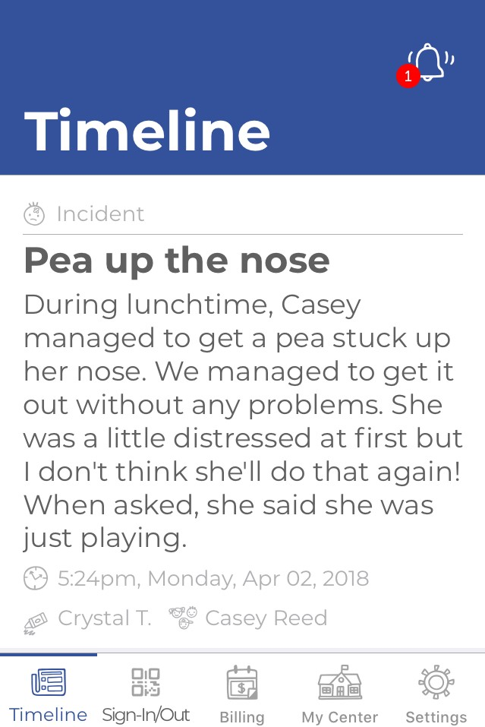

Reply to an Entry
- Tap on an entry to open it.
- Tap Add a comment at the bottom and enter your message.
- Tap the arrow on the right when finished.

Notifications
Notifications let you know that timeline entries have been made from the childcare staff and are ready for your review. Notifications show as a red icon above the Bell icon and are accessible from any Smartcare page you have open. You can set which notifications you prefer to be made aware of.

Review Notifications
- Tap the Bell icon in the top right of the screen. The Notifications screen opens.
- Scroll to review notifications.
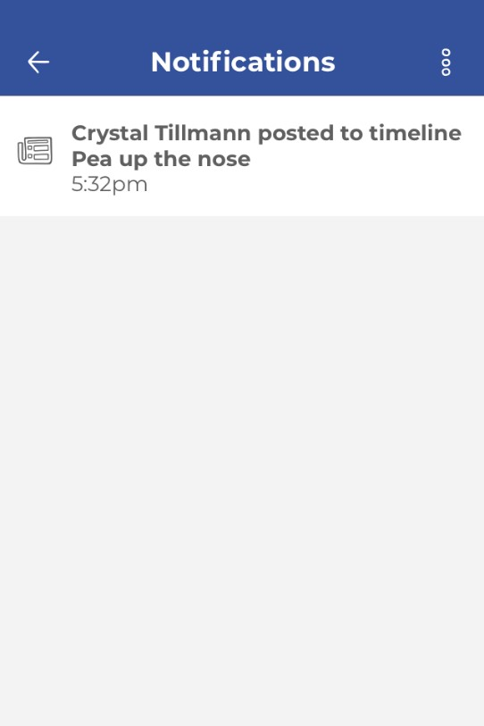

Mark a Notification as Read

- Tap the Bell icon in the top right of the screen. The Notifications screen opens.
- Tap on a notification to view details. This automatically marks it as read.

Set Notifcations Preferences
- Tap Settings at the bottom menu. The Settings screen opens.
- Tap Notification Preferences.
- Select which notifications you want to receive by tapping the circles.

My Info

Edit Personal Information
- Tap Settings at the bottom menu. The Settings screen opens.
- Tap Profile. Your Profile opens.
- Tap on a field to update information.
- Tap Save when finished.

Add Profile Photo
- Tap Settings at the bottom menu. The Settings screen opens.
- Tap Profile. Your Profile opens.
- Tap Add Photo and follow the prompts.

View Kiosk Access PIN
- Tap Settings at the bottom menu. The Settings screen opens.
- Tap Profile. Your Profile opens.
- Tap Show PIN to see your personal Kiosk access PIN.
Note: If your center has switched from an 8-digit PIN to a 4-digit PIN, your 4-digit PIN is the last four digits of your 8-digit PIN.

Billing

Review Billing Statement
- Tap Billing at the bottom menu. The Billing screen opens.
- Scroll to review your account summary and a list of statements.
- Tap on a statement date to open and view details.

Setup Payment Method
- Tap Billing at the bottom menu. The Billing screen opens.
- Tap Settings. The Payment Settings screen opens.
- Tap Add a Credit Card or Add a Bank Account and enter the required information.
- Tap Save.
- Go back to the Billing screen and tap Settings again.
- Tap the circle next to the payment method to mark it as the default method.

Change Payment Method
- Tap Billing at the bottom menu. The Billing screen opens.
- Tap Settings. The Payment Settings screen opens.
  - To Delete Payment Method: Tap on the payment method in the list and tap the Trash icon.
  - To Add a Payment Method: Tap the + icon at the bottom right of the screen, select payment method and enter the required information.
  - Tap Save when finished.

Make a Payment
- Tap Billing at the bottom menu. The Billing screen opens.
- Tap Pay Now and follow the prompts to process payment.

Getting Started for Android
Welcome to Smartcare! This guide is to assist you with using the Smartcare Parent App for Android.
Upon enrollment in your childcare center you will receive a confirmation email with a link to set up your password and PIN. If you did not receive your confirmation email, please contact your childcare center.

Download the Application
- On your Android, open the Play Store and search for Smartcare for Parents.
- Tap Install to download it.

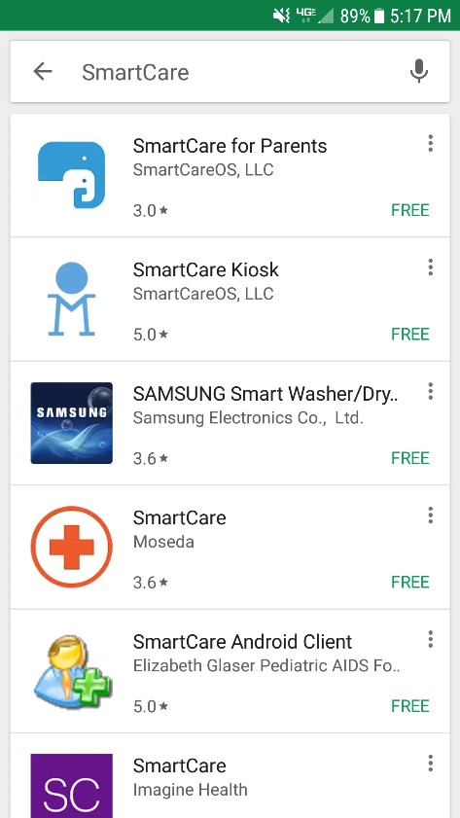

Log In to Your Account
- Tap on the app to open it.
- Enter your email and password.
- Tap Login. The Timeline displays by default.

Reset Your Password
- On the Login screen, tap I Forgot Password at the bottom of the screen.
- Follow the prompts to reset your password.

Log Out
- Tap Settings at the bottom of the screen. The Settings screen opens.
- Tap Logout and then Yes to confirm.

Change Your Password
- Tap Settings at the bottom of the screen. The Settings screen opens.
- Tap Change Password.
- Enter your current password.
- Enter your new password and then enter it again to confirm.
- Tap Change Password.

Technical Support

Access the User Guide
- Log in to the Smartcare for Parents app.
- Tap Settings at the bottom of the screen.
- Tap User Guide.
- Tap Download now! to open and view the user guide.

Report a Technical Problem
- Shake your phone until the How can we help you? prompt opens.
- Tap Report a Problem.
- Use the draw tools to mark up the screen shot if desired, then tap Report a Problem at the top.
- Enter your email and a description of the problem.
- You can also take a screen recording, take a photo, or attach a photo from your phone (tap the options at the bottom).
- Tap the Send icon at the top right of the screen.

Contact Us
Phone: 1-844-SMARTER
Email: support@smartcare.com

Using Parent App for Android

Sign In/Out to Your Center
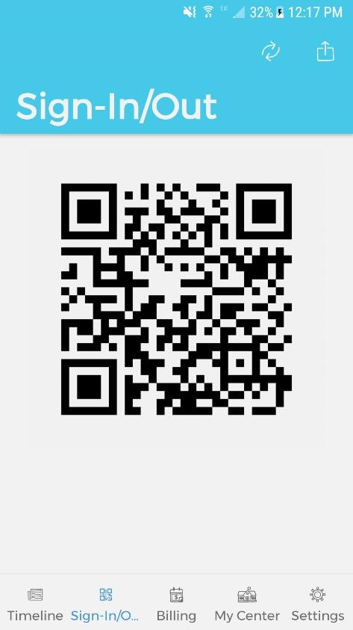
- Open the app and log in.
- Tap Sign-in/Out at the bottom menu. The QR code opens.
- Place the code in front of the Kiosk camera.
- Tap on the circle next to the child you are signing in or out.
- Tap Login. The Timeline displays by default.

Refresh Your QR Code
1. On the Sign-in/Out screen, tap the Refresh icon at the top. The QR code with automatically refresh.

Send Your QR Code for Emergency Pick-up Person
- On the Sign-in/Out screen, tap the Upload icon at the top. You may be asked to allow Smartcare to access your photos and media. In order to send the QR code, you must confirm to allow this action.
- Tap on any communication app displayed to begin the messaging process.
- Follow the prompts within the communication app you selected.

Timeline
Timeline entries give you insight into what your child is doing throughout the day. Entries are made by chlidcare staff.

Reading Timeline Entries
- The Timeline opens by default whenever you log into the app. If you’re on a different screen, tap Timeline at the bottom menu to open it.
- Scroll to review timeline entries.

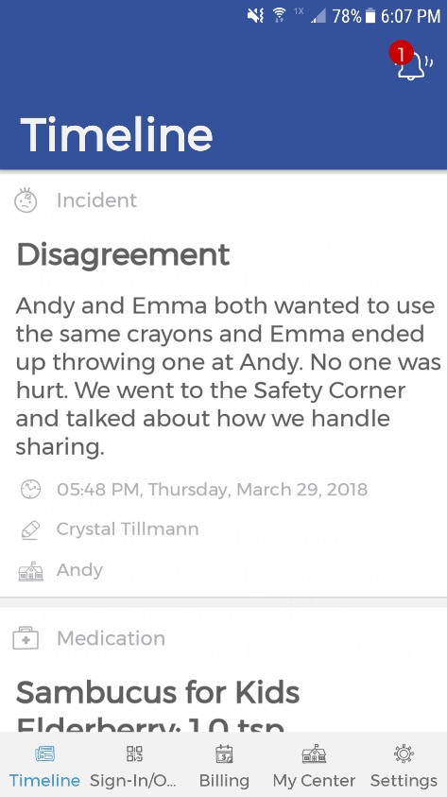

Reply to an Entry
- Tap on an entry to open it.
- Tap Add a comment at the bottom and enter your message.
- Tap the arrow on the right when finished.

Notifications
Notifications let you know that timeline entries have been made from the childcare staff and are ready for your review. Notifications show as a red icon above the Bell icon and are accessible from any Smartcare page you have open. You can set which notifications you prefer to be made aware of.

Review Notifications
- Tap the Bell icon in the top right of the screen. The Notifications screen opens.
- Scroll to review notifications.
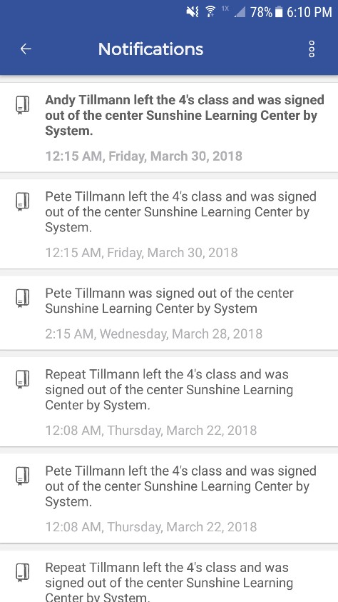

Mark a Notification as Read
- Tap the Bell icon in the top right of the screen. The Notifications screen opens.
- Tap on a notification to view details. This automatically marks it as read.

Set Notifcations Preferences
- Tap Settings at the bottom menu. The Settings screen opens.
- Tap Notification Preferences.
- Select which notifications you want to receive by tapping the circles.

My Info

Edit Personal Information
- Tap Settings at the bottom menu. The Settings screen opens.
- Tap Profile. Your Profile opens.
- Tap on a field to update information.
- Tap Save when finished.

Add Profile Photo
- Tap Settings at the bottom menu. The Settings screen opens.
- Tap Profile. Your Profile opens.
- Tap Add Photo and follow the prompts.

View Kiosk Access PIN
- Tap Settings at the bottom menu. The Settings screen opens.
- Tap Profile. Your Profile opens.
- Tap Show PIN to see your personal Kiosk access PIN.
Note: If your center has switched from an 8-digit PIN to a 4-digit PIN, your 4-digit PIN is the last four digits of your 8-digit PIN.

Billing

Review Billing Statement
- Tap Billing at the bottom menu. The Billing screen opens.
- Scroll to review your account summary and a list of statements.
- Tap on a statement date to open and view details.

Setup Payment Method
- Tap Billing at the bottom menu. The Billing screen opens.
- Tap Settings. The Payment Settings screen opens.
- Tap Add a Credit Card or Add a Bank Account and enter the required information.
- Tap Save.
- Go back to the Billing screen and tap Settings again.
- Tap the circle next to the payment method to mark it as the default method.

Change Payment Method
- Tap Billing at the bottom menu. The Billing screen opens.
- Tap Settings. The Payment Settings screen opens.
  - To Delete Payment Method: Tap on the payment method in the list and tap the Trash icon.
  - To Add a Payment Method: Tap the + icon at the bottom right of the screen, select payment method and enter the required information.
  - Tap Save when finished.

Make a Payment
- Tap Billing at the bottom menu. The Billing screen opens.
- Tap Pay Now and follow the prompts to process payment.

